Bachelor of Computing (Electronic Commerce)
University of South Australia

Assignment Cover Sheet

Course Name: | Introduction to E-business
Student Name: | Wong Chun Nam, Ruga | Wu Ka Ho, Eric | Hon Fuk Kwong | Wong Wan Ki | Cheung Tak Wa | Chen Hung Yung
UniSA Student ID: | 100023276 | 100021416 | 100037890 | 100056293 | 100037873 | 100037867
SCE Student ID: | 3628582 | 3628396 | 4607376 | 5632323 | 4607546 | 04607449
UniSA Email ID: | Woncn002 | Wuykh001 | Honfk001 | Wonwk010 | Chetw001 | Chenhy048
Assignment Name/Unit No.: | Assignment 1
Assignment Deadline: | 29 ,March ,2006
Date of Submission: | 30 ,March ,2006

Plagiarism Statement

I/We declare the following to be my own work as understood by the University’s policy on plagiarism, unless otherwise indicated.

Ruga Eric Drerk Ki Wa Leo
Student’s Signature: _________________________________
Table of Content

1.0 Introduction P.2

2.0 Road for Mircobusiness to e-Business P.3

3.0 System planning P.5
3.1 Value proposition
3.2 Revenue model
3.3 Market opportunity
3.4 Competitive environment
3.5 Competitive advantage
3.6 Market strategy
3.7 Organizational development
3.8 Management team

4.0 Hardware & Software Requirement P.9

5.0 Building the system: inhouse vs. outsourcing P.10

6.0 Suggestion to add on microbusiness P.11

7.0 Conlusion P.12

8.0 Reference P.13

Introduction

During the 20th century, our society across the board witnessed a widespread adaptation of Computer and Internet technology. Under this encouraging environment, many businesses became Internet-based, meaning that the main sales channel is through web selling. Amongst the various business structures, Microbusiness tends to adapt to e-business slower and has a higher failure rate. Microbusiness refers to business that employs less than five employees, with small-scale investment, and their road of adaptation to electronic commerce usually begins with inhouse resourcing. This report leans its focus on the outlining of the common factors that hinder the start up of e-business in Microbusiness and aims to provides solutions in how to overcome those obstacles. The report begins with an introduction of Microbusiness and e-Business. Also there will be a comparison of Microbusiness and larger corporate business, and the lessons that Microbusiness might learn from large corporate business in the implementation and ongoing management of e-business & solutions, as well as the way in which Microbusiness might take to overcome the typical problems such as system functionality and staffing issues. There will also be a short discussion on the information requirements necessary for e-business to kick start and hopefully succeed. At last, we will provide a summary on how well traditional business can adapt to, and benefit from the introduction of e-business.
What is Microbusiness?
A small business that, together with affiliates, has an average annual gross receipts of two million five hundred thousand dollars ($2,500,000) or less over the previous three years, or is a small business manufacturer with 25 or fewer employees.
(California, http://www.pd.dgs.ca.gov/smbus/mbdef.htm, viewed on 25-Mar-2006)
What is e-Business?
The digital enablement of transactions and processes within a firm, involving information systems under the control of the firm.
(Kenneth C.Laudon & Carol Guercio Traver, E-Commerce: business, technology, society, 2nd edition, Addison Wesley, P.10)
2.0 Road for Microbusiness to e-Business
First of all, Microbusiness refers to business that has only a handful of staff or are non-employing sole proprietors. Before all else, these Microbusinesses are faced with human resource constraint. The limited number of staff is usually employed to meet the day-to-day operational functions. Instead of having a full time dedicated IT personnel like most larger businesses do, logically, anything that is computer-related will be an add-on task for the staff who possesses most knowledge of computers, usually someone, young and willing to take on new challenges, who had experience of using computers from school to the handling their personal matters. The focus of such staff, will therefore, not be focally directed at developing any IT-related matters., , hence will not be capable of starting up e-business from scratch
At the same time, Microbusiness typically has less financial resources; little if any expertise other than what is required specifically for running their business, and limited access to information.
According to statistics provided by the Australian Bureau of Statistics (ABS) only 64% of Microbusiness has Internet Connectivity, so immediately there is 1/3 of these businesses that are nowhere close to starting up e-business.
In order to start up an e-business function, the business must be able to meet four pre-requisites, namely:
- Purchasing a computer
- Establishment of Internet Connectivity
- Building an Internet presence
- Introduction of electronic commerce functionality
In making the decision to purchase a computer, the business must first determine the configuration which suits the business’ needs, should it be a desktop or a laptop, the necessary storage space required, the appropriate speed and random access memory, software that will enable the business to go online, the kind of browser and email program to install. These are all very technical knowledge that the owner or its employees might not possess. Furthermore there will be another financial decision to make, the owner will have to determine whether it makes more financial sense to purchase the computer or to lease it.
Once the hardware and software have been purchased or leased, one has to select the appropriate connectivity, ie. ISP. One must choose between narrowband and broadband and the choice should be cost-effective and should reflect on how many people will be sharing the network and that the system should be sufficient to handle the traffic. The higher cost of broadband might present an expense problem for Microbusiness. In a lot of the cases, additional phone lines will have to be installed so that by getting connected, the usual business lines are not jammed up.
The next step will be to establish an Internet presence and each step gets more complicated and will require more knowledge, time and financial resources. ISP, which provides reliable connectivity, might be able to offer web capabilities, the service will be provided at an additional monthly or annual fee. This again is an additional cost to the business. Unless a current employee has the expertise to set up a web page, or else, the business will need to hire outside help in web design and web page design can be rather costly and the price usually reflects the quality of the design. In turn, the quality of the web page will be a direction reflection of the business and a poorly designed web page might end up doing more bad than good for the business. Maintaining a web page will also require extra money and manpower. Having gone through the trouble in acquiring all the equipment and the hours spent in getting everything connected, small business owners will hate to realise that all efforts are wasted when the time could be better spent on what they traditionally do in generating business!
The final step will be to set up online payment system, be it manual or automatic, so that the business can truly realise the gains from its expansion to electronic commerce. The business will need to meet with banks and arrange merchant bank agreements for receiving payments via email (without customer signatures). In the eyes of the banks, this kind of payment usually involves higher default rates as Internet fraud is becoming increasingly commonplace. The banks will usually charge a higher merchant fee as a reflection of the risk involved. Additional e-commerce functionality might be required so that customers can shop through the online catalogue and make payments efficiently and securely.
The set up and the maintenance of e-commerce as an ongoing integral part of the business requires much detailed planning, financial resources, human resources and how it might be structured so that the e-commerce better enhances the business flows and that the costs and time involved are reflected in the positive increment of sales volume and money flow. They are the main challenges that Microbusiness face in their adaptation of electronic commerce.
An example from Google, they provide Google AdWords and Google AdSense. Which advertisement cost is not high but have a higher 50%up rate button click compare with not apply advertisement in Google.
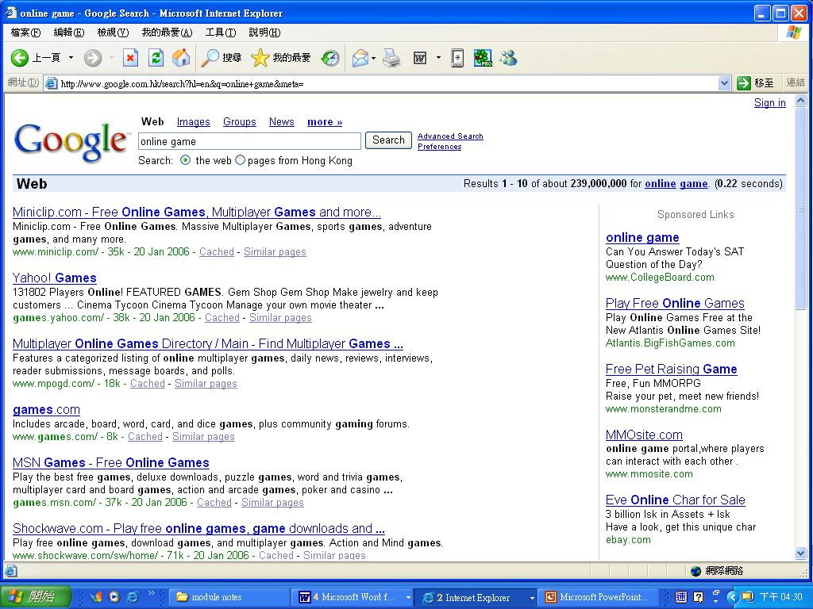
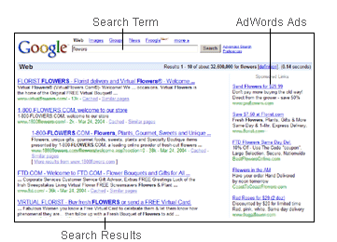 (Fig 2.1b Advertisement show while search from engeer)

(Fig 2.1a Google provide AdWord advertisement to company or other business)

3.0 System Planning
From the report of Lawrence, we can clearly found that the speed at which consumers are getting connected to the Internet and the rate at which purchasing over the Internet is becoming mainstream – with over 79% of computer adoption, in short e-Business provides marketers with greater opportunities in electronic commerce. e-Business is positioned to explode in the next few years. Traditional marketing models may not be equipped with tools that will explain online consumer behavior. Such differences between store retailing and online retailing include the physical separation of the buyer and seller, the absence of a salesperson, the separation of the product and the buyer, and the ability of marketers to immediately update product, price, and distribution information. These differences represent threats to e-marketers that must be overcome for consumers to initiate a purchase online. The Internet has also brought the buyer and the seller closer than they have ever been before. Where previously consumers may have been limited by the location of a business when making a purchase, the Internet has provided a worldwide forum for businesses, products, and services. Consumers now have access to many more businesses and what they have to offer in variety, price, origins from all over the world and at the click of their keyboard, any hour of the day. As a result, we also need “bricks & clicks” to allow customers to make the choice of shopping through the Internet or to physically visit the real store. Below is a discussion of the similarities and differences of marketing strategies as employed by Microsbusiness and Large Coporations.
(Building Trust to Develop Competitive Advantage in e-Business Relationships, Warrington, Traci B.; Abgrab, Nadia j.; Caldwell, Helen M., viewed on 26-Mar-2006, http://www.allbusiness.com/periodicals/article/719279-1.html)
3.1 Value proposition
This is the reason why customer(s) buy your product or serivces. In Mircobusiness, if the business is to provide horse race gambling information or tips, one must have a system to maintain the most updated information and show the tips rating for the customers in the most timely and reliable manner. If our business is an online florist, one must be able to have a simple and detailed information acquisition process and the actual order process should be simplied and time-efficient compared to physically visiting the florist to order some flowers. To a lot of people, time is money. One of the main reasons why online shopping succeeds is that people can do their shopping without going out and that saves time, Bearing in mind, if the product is inferior in quality, or the delivery is unreliable, people will revert to the traditional shopping method though it costs them time. This again ties back in with our discussion that a web presence is great, but staff must be taking the orders and delivering the product just as what their websites have promised.
3.2 Revenue model
According to the revenue model, large corporate business and Microbusiness are somewhat similar, despite their differences in scale and scope, they both are sellers of goods and/or services.
3.2.1 Content Sites.
Referring back to the previous sample of a gambling website which receives bets from customers and its revenue flow is derived from the people who register as their site members, especially -as VIP type members - where additional information or premium services are provided.
3.2.2 Direct-Sell Sites.
Using the same example of an online florist, as the sellers canprovide a series of packaged deals in various price range, for different occasions and will usually include delivery service. Customers will usually make payments through secured payment channels such as the *‘Paypal’ payment method.
3.2.3 Dot-Com E-Tailers.
Not dissimilar to the direct-sell revenue model, due to the limited investment (ie. Not having its own online direct payment mechanism), payments can be received from the customers through the *‘Paypal’ payment method, though additional charges will be paid out to these intermediaries.
3.3 Market opportunity
Whilst large corprate business mainly serve the B2B, B2C market, Microbusiness on the other hand, also serve the C2C market.
3.3.1 Content Sites.
Content sites focus primarily on the provision of information, entertainment or any other content related matters. For example, showing horse race gambling information or online forex trading sites where real time forex quotes are updated with almost no time delay and members can register to trade in the foreign exchange market online as opposed to opening an account with a bank and trading through bank managers
3.3.2 Direct-Sell Sites.
Direct-sell sites are web sites through which a company sells its own products. For example, - back to the online florist example, where the florist would host a series of flower arrangements in their various designs, price ranges and for different occasions. Customers upon visiting the site, can order the flower arrangement, choose the price range, input delivery details such as recipient, his/her contact information and payment can be made instantaneously. They are selling something that they produce, ie. Own flower arrangement and not products that are manufactured or produced by a third party.
3.3.3 Dot-Com E-Tailers.
Dot.com e-tailers generally refers to web sites that resell products or services produced by other company. Generally speaking, these web companies will have ways of sourcing products at a discount and arbitrage from their discounted wholesale costs to the the normal market price. In addition, there are times that these web companies can get their hands on products that are of limited edition or no longer in production, which might have been sold out in the market or has a waiting list where most buyers cannot get their names down for, and they might even be able to sell these products at a premium. A lot of these dom.com e-tailers will utilise reputable auction sites such as yahoo.com or ebay.com as their main marketing channel.
3.4 Competitive environment
The competitive environment in which Mircrobusiness face and that of larger corporations might be different. Most large coporations serve the mass market whilst Microbusiness are more focused on the niche market. To a certain degree, this might explain why the failure rates of Microbusiness can be as high as 64%, as a business must have a thorough understanding of a niche market in order to succeed as its focus is in a very small niche group and once that focus or market positioning or pricing is miscalculated, a small business can go under within a short period of time.
3.5 Market strategy
In terms of market strategy, both large business and small business are able to use similar marketing tools, such as hosting an advertisement from frequently-visited sites as Google or Yahoo. Sending email to prompt customers about race gambling tips or products such as flash disk or flash memory usually come at a lower cost than advertising in the traditional ways and can achieve the same quality and warranty.
3.6 Organizational development
About 64% of Microbusiness developers are non-employing sole proprietors, hence the corporate structure of Microbusiness is usually not as well-segregated, organized or managed as large businesses are.. This often brings about problems such as IT knowledge know-how, or issues such as how much time the sole runner of the business can dedicate to e-business when he or she has to manage everything from top to bottom himself or herself. Outsourcing of IT experts can help mitigate this problem but then it will also introduce extra costs to the business which it may, or may not be able to afford. As discussed earlier, a poorly managed web presence might bring on more problems such as the projection of a poor corporate image or lack of timely information, than benefits. It then could turn into a self-perpetuating prophecy and explaining the high failure rates of Microbusiness conducting e-business.
3.7 Management team
A staggering of 89% of Microbusiness employ less than 5 employees and professional training is inadequate, staff usually learn about the job through trial and error. Proper training, if present, is usually insufficient and infrequent. Compared to corporate giants such as REI, Microbusiness may not have a well-structured management team and the managerial decisions usually focus on day-to-day operation. Faced with the lack of human resources, managers in Microbusiness typically have little time to evaluate larger issues as such the future expansion of the company; hence have less foresight on how e-business might be able to generate growth for the company.

4.0 Hardware & Software Requirement
 | Microbusiness | REI company
Server side (Hardware) | - Intel Pentium 4 1GHz or above  - 256 MB RAM or above  - Hard disk with at least 30 GB  - Ethernet network interface card  - CD-Writer drive for backup client’s database | - Mainframe x1  - AS/400 x1  - RS/6000 x4
Server side (Software) | - Microsoft Access or MySQL Server Database  - Microsoft Windows 2000, XP or Windows Server Platform  - IIS Service installed | - Unix as OS  - Oracle as DB  - Apache as web server  - Inhouse design web application
Server side (Security) | - TCP port 80 opened for IIS Service | - Secure port, such as 443  - Common HTTP port 80
Client side (Hardware) | - Intel Pentium 4 1GHz or above  - 256 MB RAM or above  - Hard disk with at least 2 GB  - Ethernet network interface card  - CD-Writer drive for backup client’s database | - Nil
Client side (Software) | - Windows platform (XP prefer)  - Internet Explorer 6.0 or above | - Nil

5.0 Building the system: inhouse vs. outsourcing
After the consideration of setting up an e-Business, one would need to make the decision on whether the website design, execution, ongoing maintenance should be outsourced or done inhouse. In the past, taking on additional project work within the existing staff has proved to be difficult for many small companies - especially where technological know-how of the current staff base was limited. Technical expertise often comes as a premium to what traditional salespersons would cost the company in wages and there was often a lack of understanding between the business and technical employees. Over the past few years, many non-IT employees have proved to work very effectively to help deliver e-Business projects and opens up a lot of options for many companies. With more and more people being computer literate, small companies are able to implement computer-based work with less resistance and enhanced efficiency. With the case study in both REI & Lawrence, there were four areas where the inhouse/ outsourcing choice is outlined:
- Project Management
- Definition of Strategy and Scoping Requirements
- IT Development Work
- Ongoing technical support, maintenance, user training, minor improvement etc.
(Data Warehousing And Business Intelligence For e-Commerce, Alan R. Simon, Steven L. Shaffer, P.216~218)
In the case of Project Management, most of companies chose source from inhouse resources, although the amount of time required for this kind of project was invariably underestimated. In scoping requirements, generally employ a mixture of solutions. Some did this inhouse and others employed an independent consultant. In most of cases, external consultants carried out the bulk of the IT development work. However, there was a significant trend towards strengthening the inhouse IT capabilities either by recruitment (for instance, ensuring that staff employed has a level of computer literacy) or training of non-IT staff or by a combination of both.
(State of E-Business Readiness Report, viewed on 28-Mar-2006, http://www.cstd.ca/networks/PSES.pdf)
Due to specialization of IT skills and knowledge, most of the companies choose to outsource the work. The benefit of such is that the existing staff can stay focused on the important role they play in the business and that IT experts are hired to do what they do best, without causing unnecessary delay in the implementation of the project. As for outsourcing of project management work, much as the management team tries to allocate their work to others & to delegate their managerial responsibilities to the appropriate staff, it will be impossible for management to just focus their efforts and time fully on IT-related issues.
As a result when a consultant is often brought in, to enable the company to internalise his/her knowledge and skill set in strengthening the company’s IT capabilities. Research has shown that if companies had the foresight in recognizing how time-consuming and the kind of pressure managing IT inhouse presents their managers, most would probably hire outside expertise in the first place.

6.0 Suggestion to add on Microbusiness
With all business, whether it is sales through traditional channels or through e-commerce, the business should have clearly established objectives, and to be able to match its costs and revenues to ensure that the business can stay afloat, e-business or not.
Before e-commerce is introduced to the business, the manager must carefully evaluate whether e-commerce is indeed an appropriate tool in bringing in more sales. If so, then how. Having established the vision that e-commerce will, if implemented and managed properly and efficiently, in the long run, generate growth, hence, add contribution to the bottom-line; the business will need to make necessary plans or even changes to its current corporate structure or resource allocation or staff issues as outlined earlier in this essay.
There is an increasing amount of IT magazines available and more and more people are using computers on a daily basis, be it for work or personal pursuits. The business owners can broaden its research and knowledge base by reading more on the subject or just by communicating with people who have a taken interest in the subject or better still, are already in the e-commerce business. By having a widened knowledge base and information set, the owner will be in a more favourable position to make informed decision for the business. Time that is spent on research will be rewarded as this will in turn save time and money that might otherwise be wasted, which are also the resources most Microbusiness is lacking in.
The task will be less daunting if Microbusiness has the money, time and human resources as some of the larger business, faced with limited resources, more detailed planning and precise execution will be paramount to the success of e-commerce in Microbusiness. One way to do so is, to employ staff that has at least some basic computer knowledge, someone who is interested in and not afraid to work with computers. So before the e-commerce truly takes off, these staff can divide his/her time between selling through its traditional channels, and perhaps dedicating some time in integrating computers and computer-related programs and ways to do business concurrently. To the extent possible, it might be wise for the owner to provide incentives such as subsidies to enroll in extra computer courses to its staff. The more the staff knows about computers and how they can work better and smarter with the aid of computers, the more benefits the business will be able to derived from its IT investment.
If a hardcopy catalogue exists, with the products the company sells, the owner might be able to employ a web designer to host it online update the catalogue as and when necessary. The advantage of a well-designed online catalogue is that, Internet users, from all over the world, can be shopping 7 days a week and 24 hours a day. This will help the business to expand its reach to truly an unlimited amount of customers around the clock. One suggestion will be to host well-photographed pictures of the products, with clear and succinct introduction of its functions, warranty and whatever information that is required for a customer to make a purchase decision, as though he or she were standing in the shop. The business must recognize that the information that is hosted online with its products must be precise and accurate, as it might be just what sells the product. Of course, as new products are introduced one must ensure that the online information is updated accordingly. Stripping technology aside, this might be less difficult than one might think as what is required is actually carried out by the staff selling face-to-face. All that is needed is to brainstorm the questions that customers have on their products, outline them and answer them accordingly. For instance, a FAQ (frequently asked questions) icon can be added so staff that handles online enquiries need not spend extra time in answering commonly anticipated questions. This also saves time for the shopper.
In short, the more detailed the planning, the easier will be the implementation, and the higher the success rate will be for e-commerce to help generate growth and revenue for the business. The company should re-evaluate its resources used to its generated output and to re-assess how resources should be distributed on a regular basis.

7.0 Conclusion
Based on the analysis of this report, it is only fair to draw the conclusion that the cyberspace is wide enough for both large business and Microbusiness to co-exist. With large business generally concentrating on the Mass Market and its needs, and Microbusiness focusing on its niche market. Large business can fail miserably as Microbusiness can in their implementation of e-business if detailed planning, ongoing supervision and reviews and actions are not taken appropriately. The advantage of large business is that it will have more manpower and resources so that each function is carried out by a team of specialized staff whilst in Microbusiness, staff will often have to multi task. In order to succeed, Microbusiness should research on the success stories of large business growing through their e-commerce channels and to benefit from the resources large business has employed to turn the opportunities to success.
8.0 Reference
- California, http://www.pd.dgs.ca.gov/smbus/mbdef.htm, viewed on 25-Mar-2006
- Kenneth C.Laudon & Carol Guercio Traver, E-Commerce: business, technology, society, 2nd edition, Addison Wesley, P.10, viewed on 23-Mar-2006
- Building Trust to Develop Competitive Advantage in e-Business Relationships, Warrington, Traci B.; Abgrab, Nadia j.; Caldwell, Helen M., viewed on 26-Mar-2006, http://www.allbusiness.com/periodicals/article/719279-1.html
- Data Warehousing And Business Intelligence For e-Commerce, Alan R. Simon, Steven L. Shaffer, P.216~218, viewed on 25-Mar-2006
- State of E-Business Readiness Report, viewed on 28-Mar-2006, http://www.cstd.ca/networks/PSES.pdf
- Microbusiness Training Centre, viewed on 29-Mar-2006, http://www.microbusiness.ca/program.asp
- PayPal, viewed on 24-Mar-2006, https://www.paypal.com/cgi-bin/webscr?cmd=_merchant-outside
- Lawrence. E. (2003) Internet commerce: digital models for business (3rd ed.) Milton, Qld: John Wiley, P.99~104, viewed on 23-Mar-2006

~ Thanks you for your reading ~

